

**CSE3002-**Internet and Web Programming

**J-Component Project Report**

**Title: Restaurant Information System**

**Team members:**

**Nirav Bhatt- 20BCE1597**

**Suravaram Rishabh Reddy- 20BCE1545**

**Ashlin Biju- 20BCE1367**

**Table of Contents**

|  |  |  |
| --- | --- | --- |
| **S.no** | **Title** | **Page no** |
| 1 | Abstract | 3 |
| 2 | Source Code | 3 |
| 3 | Output/Frontend | 5 |
| 4 | Databases/Backend | 9 |
| 5 | Conclusion | 11 |

# ABSTRACT:

Restaurant Management System is developed to automate the daily activity of a restaurant. The purpose of this system is to provide a service facility to the restaurant workers and also to the customers. This restaurant management system website can be used by the employees in a restaurant to handle the clients, their orders, reservation and can help them easily find free tables or place orders. The services provided are food ordering, reserving a table by the customer through online, waiter information management and menu information management

# working/snaps of code:

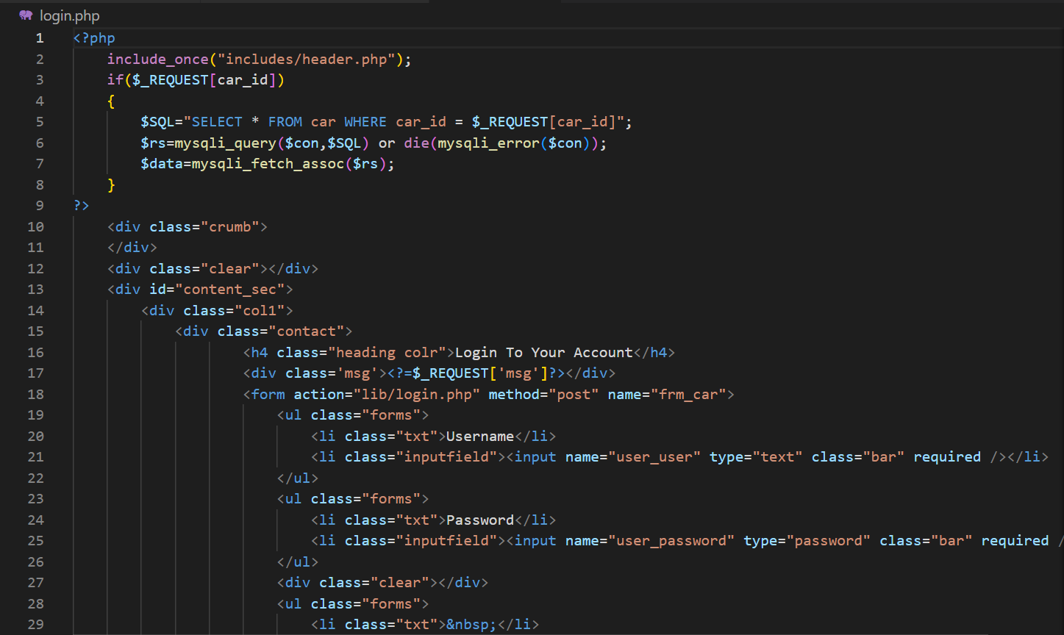

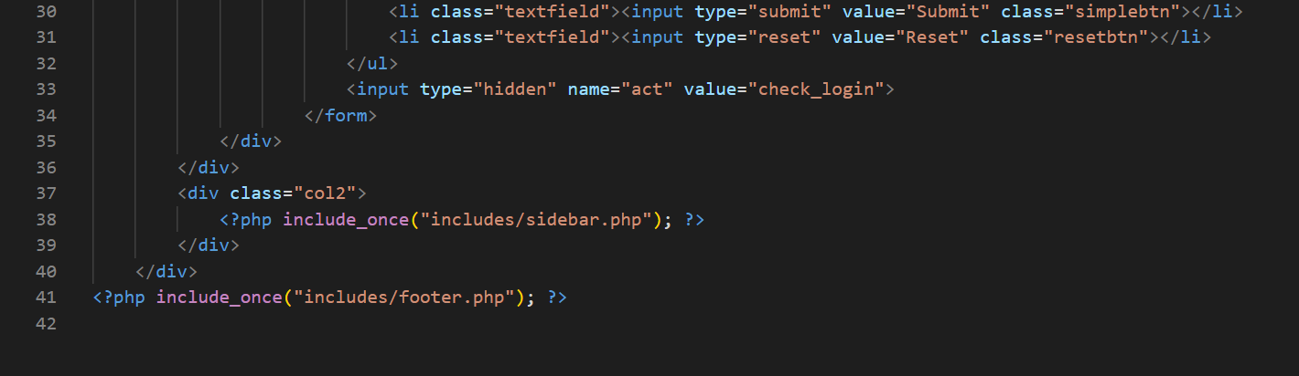

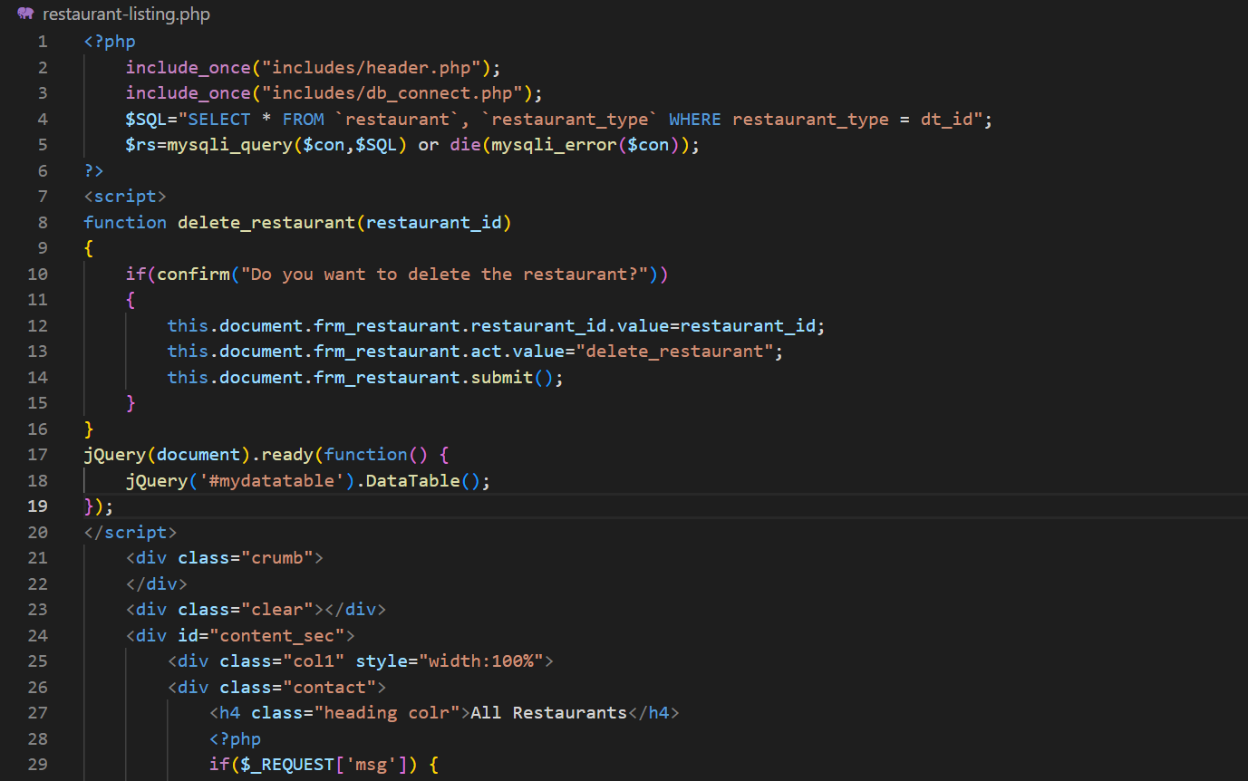

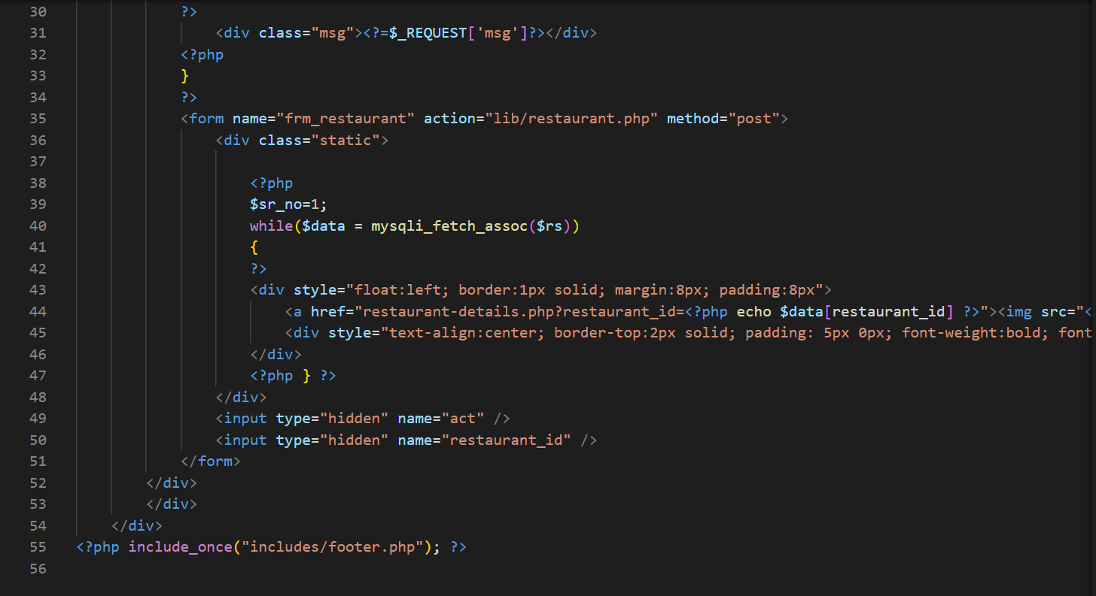

# Output:

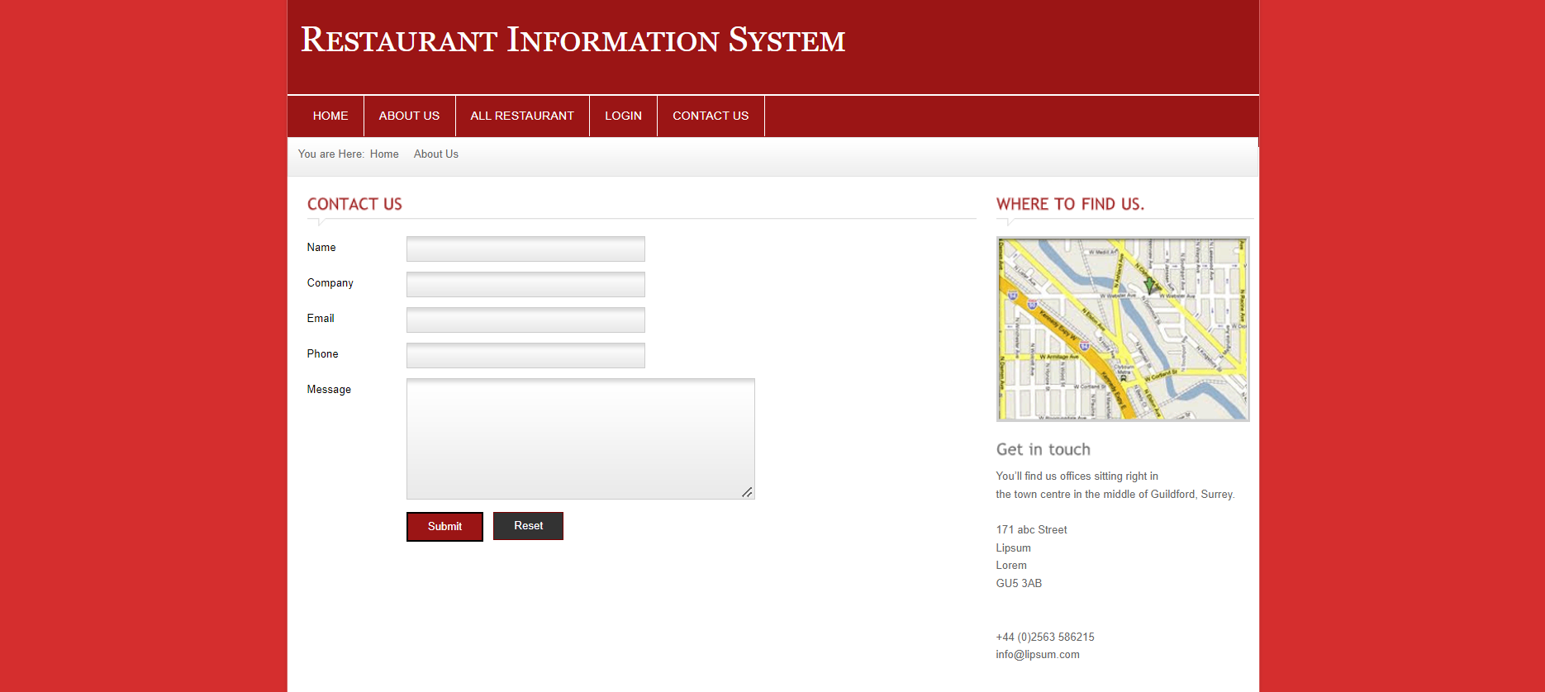

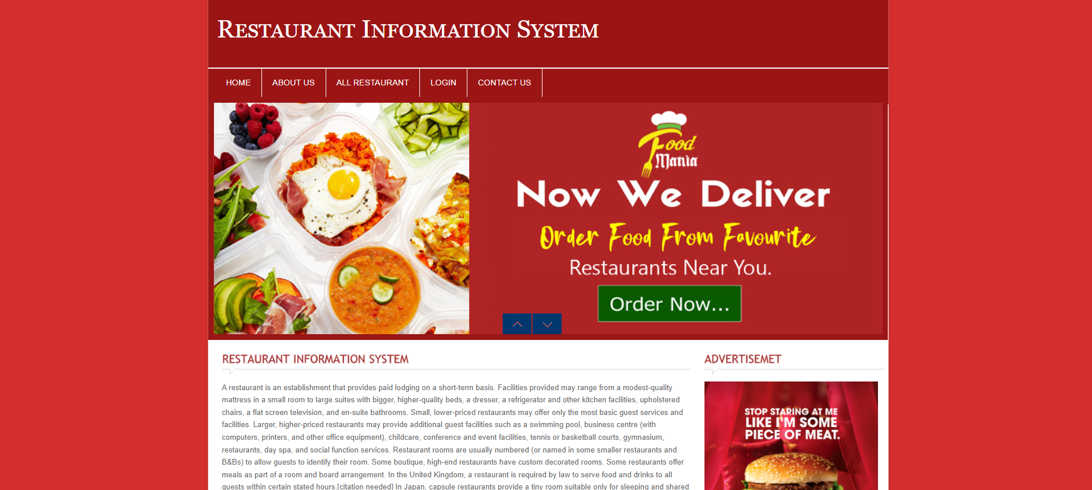

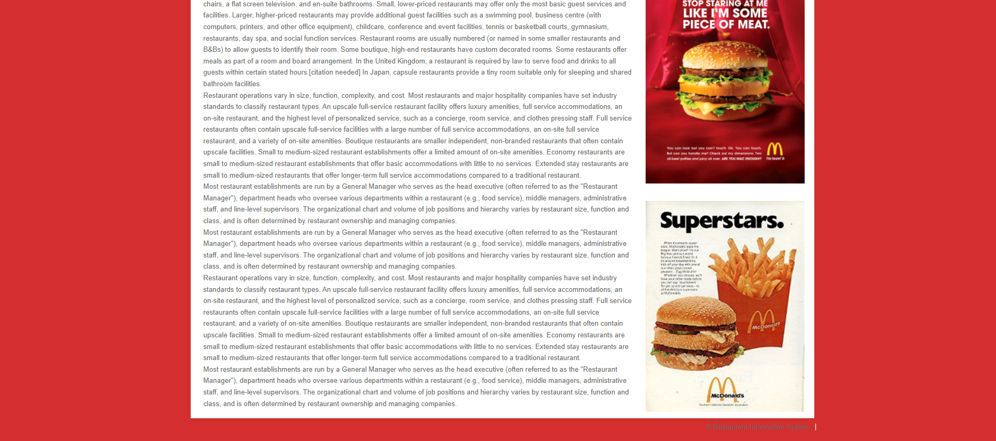

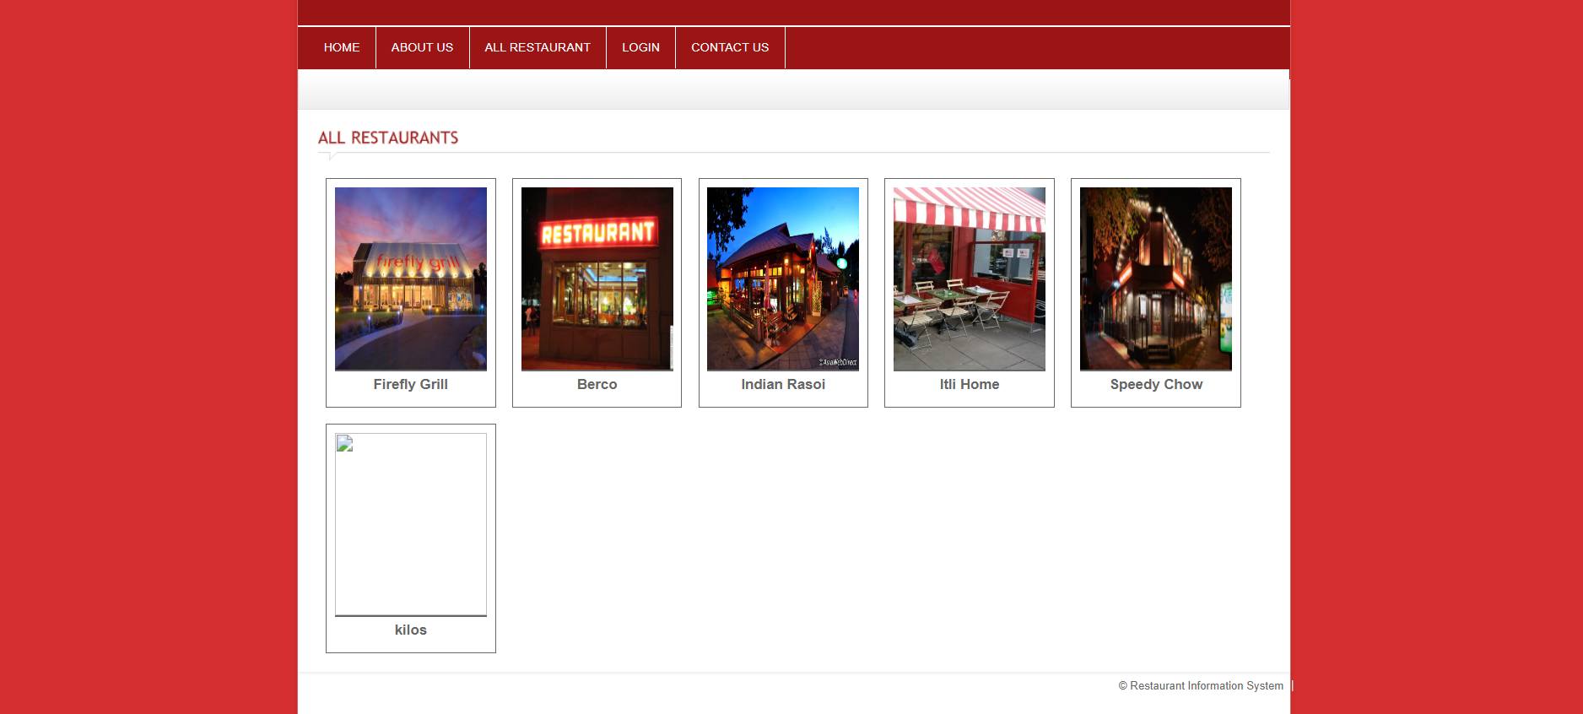

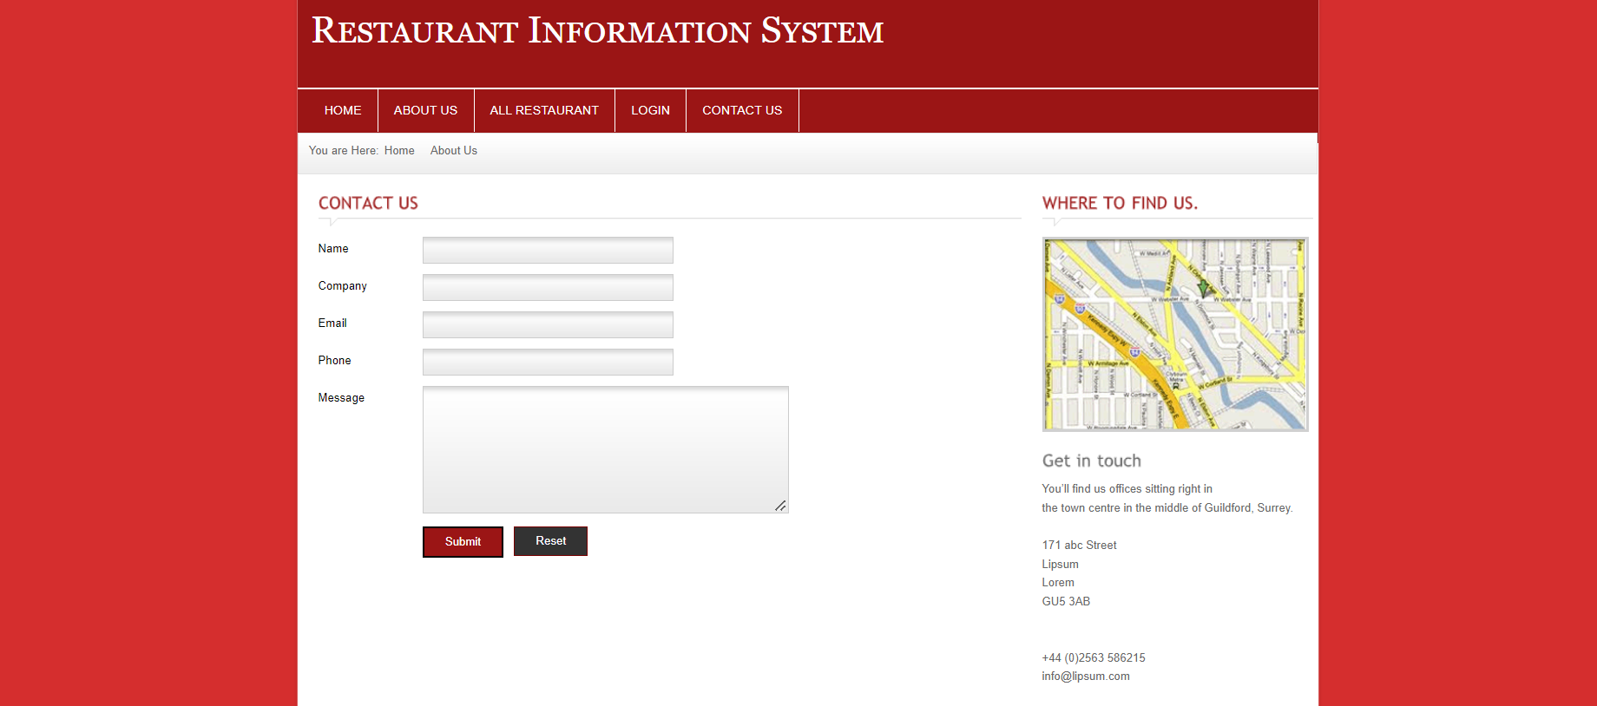

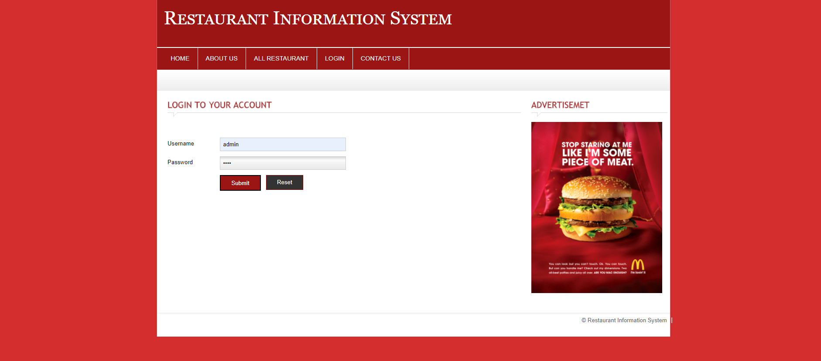

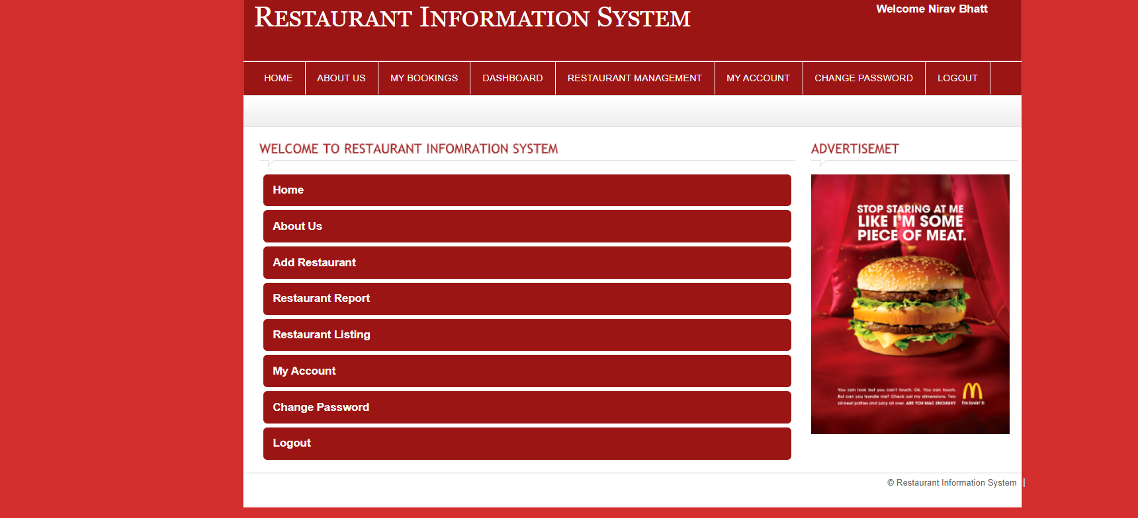

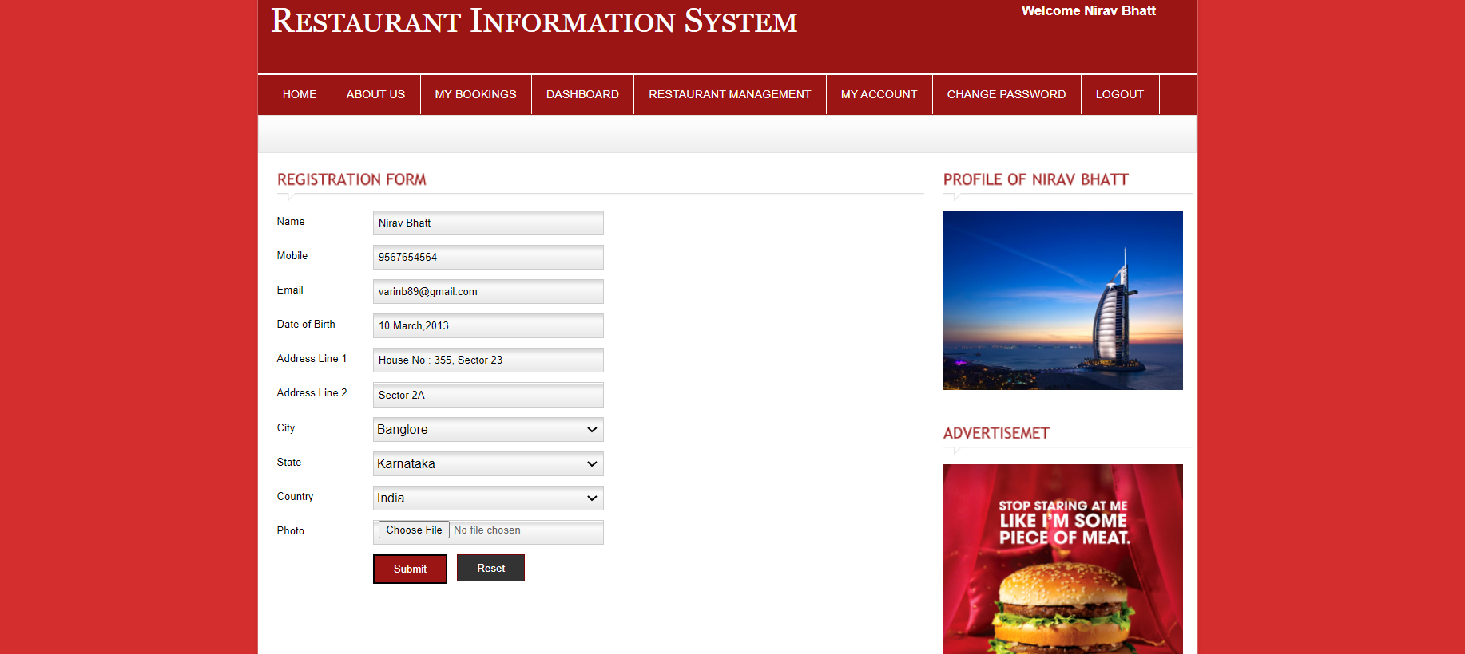

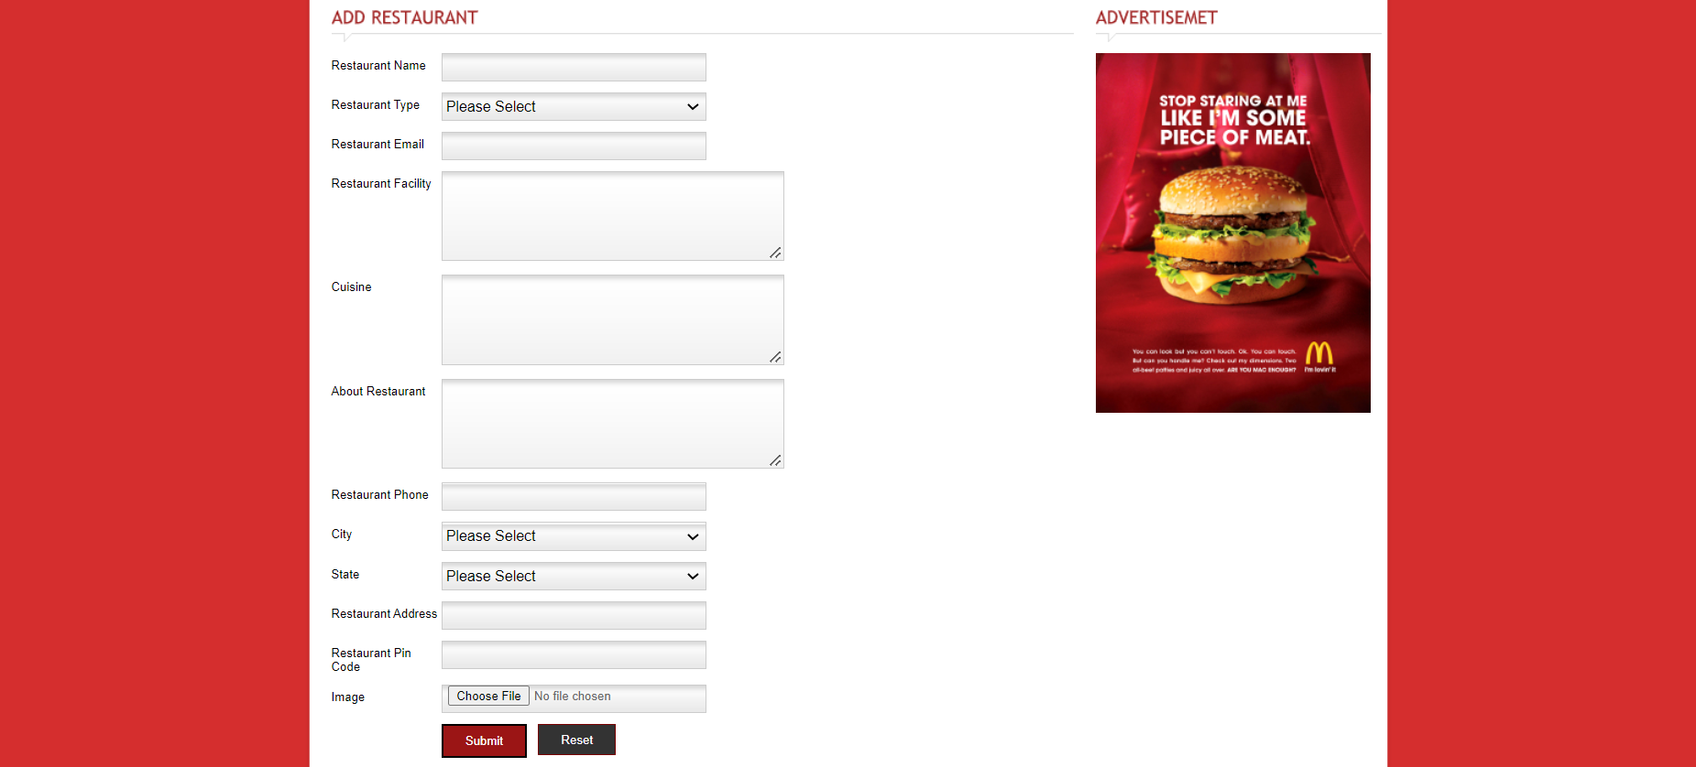

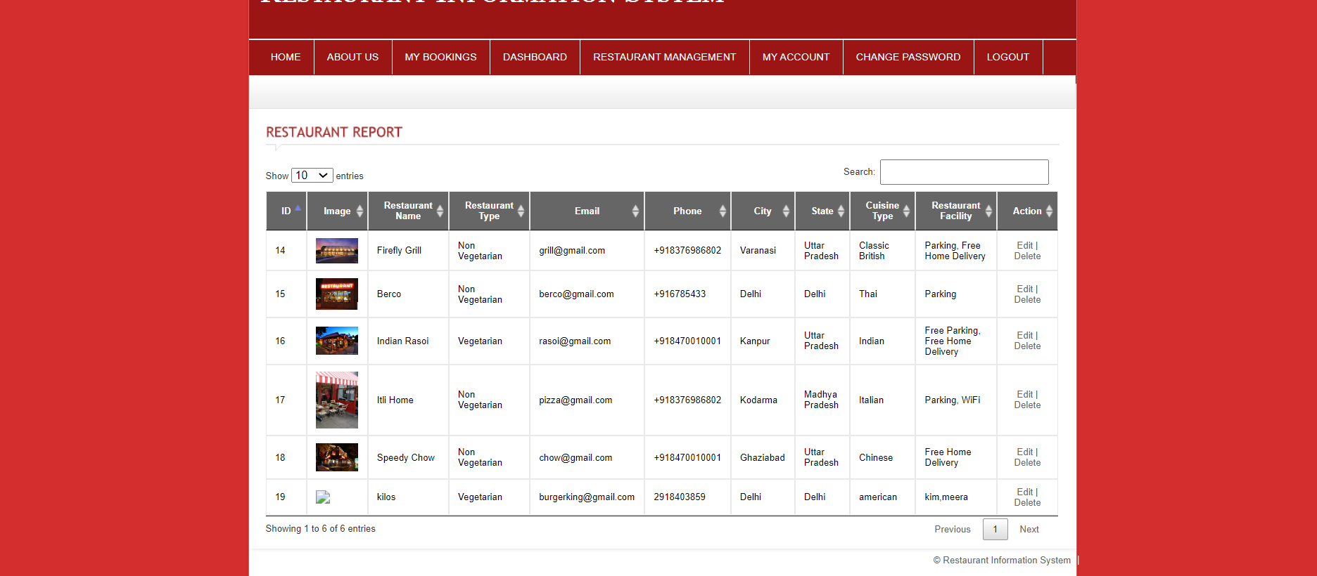

# database:

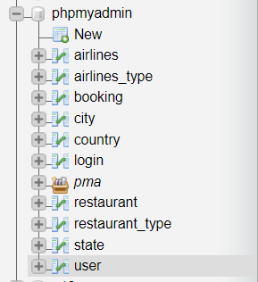

## admin Login database:

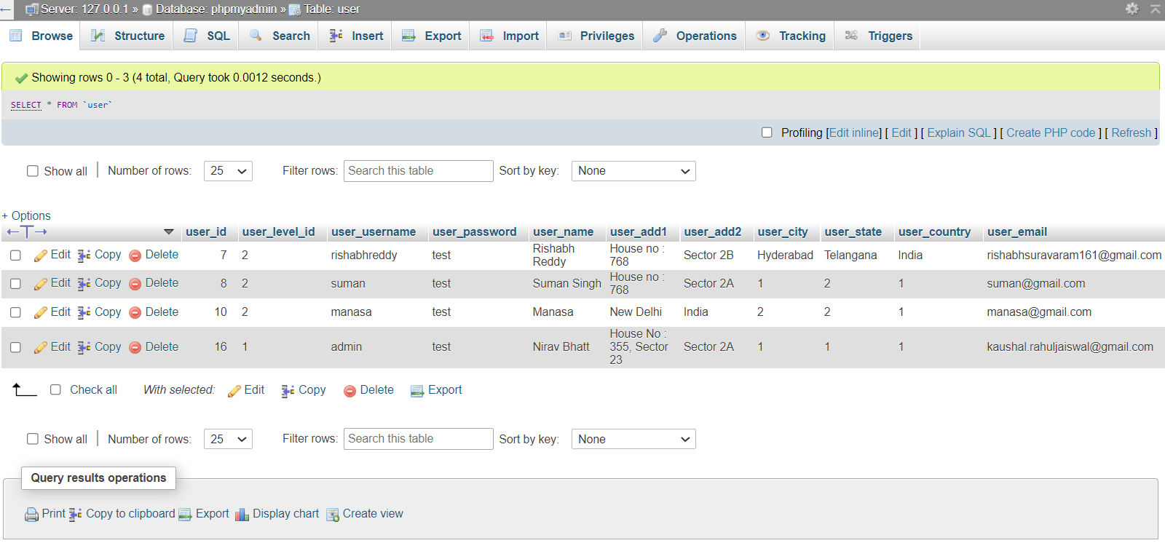

## restaurant type:

## restaurant listings:

# conclusion:

The aim of the project was to develop a system that will help customers navigate through all the restaurants seamlessly. The website not only provides the list of all the restaurants, but also its specifications, i.e., Veg or Non-Veg, Cuisine Type, Basic Restaurant Facilities, location and also provides the customers a way to contact. The website is managed by the administrators, who can add various restaurants in the category, thus giving customers more options to choose from. The major highlight of the project is that the customers are allowed to prebook their place also in the hotel for a specified amount of time, which will avoid the long-standing queues. Overall, the website benefits the customers in more ways than one, and makes their life much simpler.